
MATHS METHODS (CAS) 3 & 4
TRIAL EXAMINATION 2
SOLUTIONS
2009

SECTION 1 – Multiple–choice answers
- C 9. B 17. D
- A 10. D 18. A
- D 11. B 19. D
- E 12. D 20. B
- A 13. E 21. E
- C 14. B 22. E
- A 15. C
- A 16. A

SECTION 1 – Multiple-choice solutions

Question 1

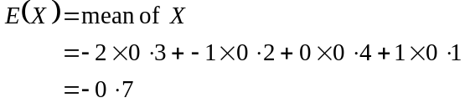
The answer is C.

Question 2

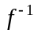 exists if f is a function.
Sketch the graph of 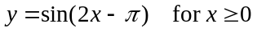.

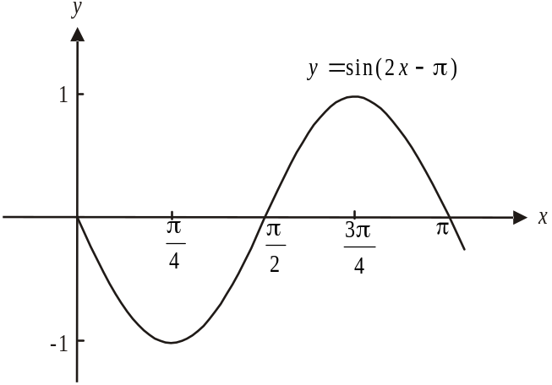

If 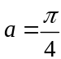, then f is a function and exists.
The answer is A.

Question 3

Sketch the function 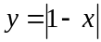.
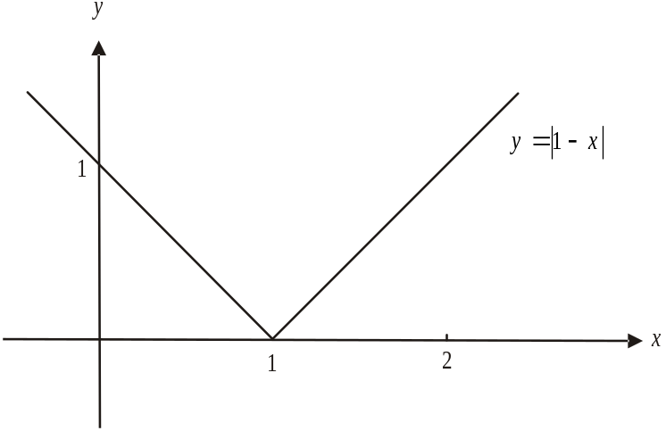

The rate of change is the gradient of the function. At 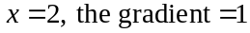.
The answer is D.

Question 4

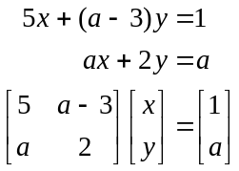
For no solutions or an infinite number of solutions the determinant equals zero.

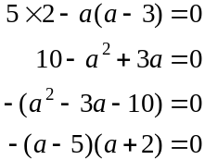

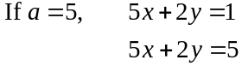
We have parallel lines, hence no solution.

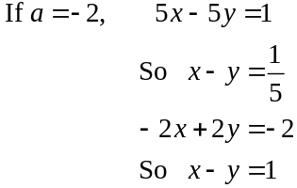
We have parallel lines, hence no solution.
So 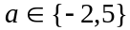 for no solutions.
The answer is E.
Question 5

This is a binominal distribution with 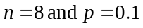.
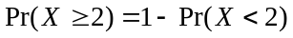
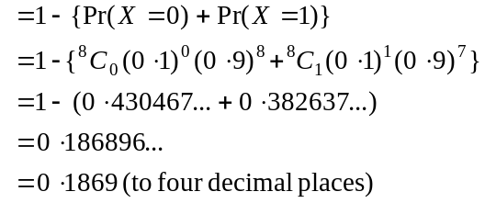
The answer is A.

Question 6
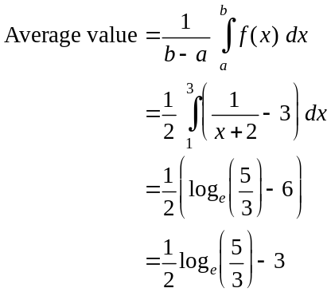
The answer is C.

Question 7

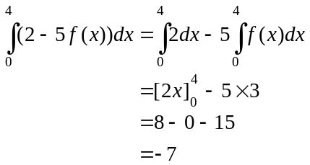
The answer is A.

Question 8
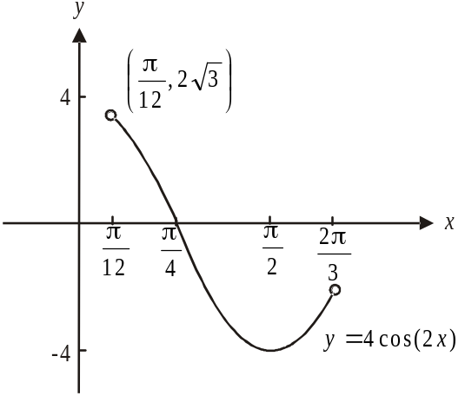

Sketch the function.
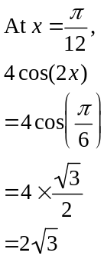
From the diagram,
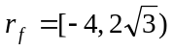
The answer is A.

Question 9

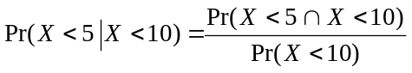
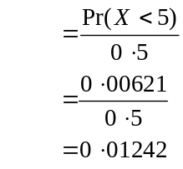
The answer is B.

Question 10

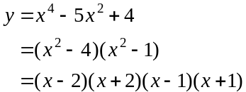
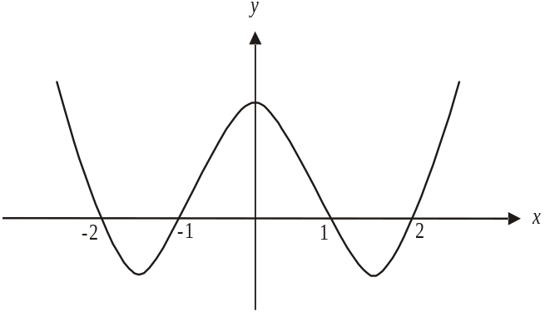

The graph is symmetrical about the y-axis.
Use your calculator to find the minimum turning points.
They occur at 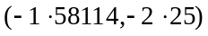 and, by symmetry at 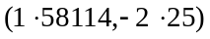.
The gradient is positive for
The closest answer is D.

Question 11

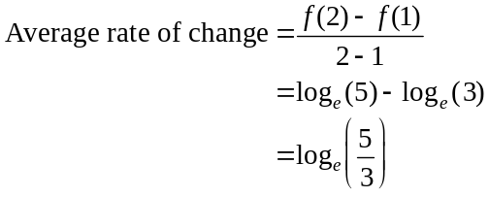
The answer is B.

Question 12

Option A is incorrect because h is discontinuous at .
Option B is incorrect because h does not exist at .
Option C is incorrect because 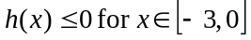.
Option D is correct because 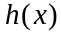 exists at .
Option E is incorrect because 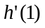 does not exist. This is because the limits for 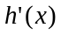 from the left and right hand side of 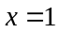are not equal.

The answer is D.

Question 13

Let 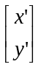 represent an image point.
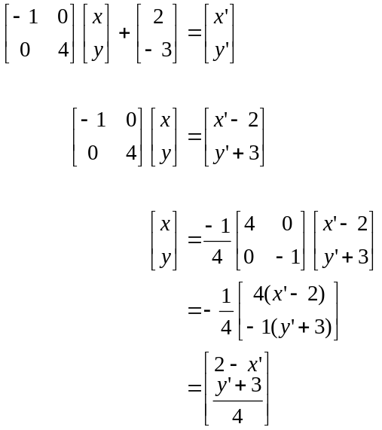
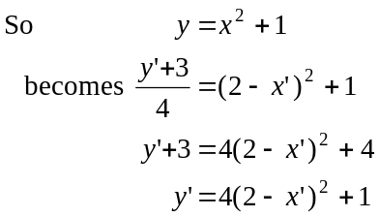
The equation of the image is 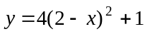.
The answer is E.
Question 14

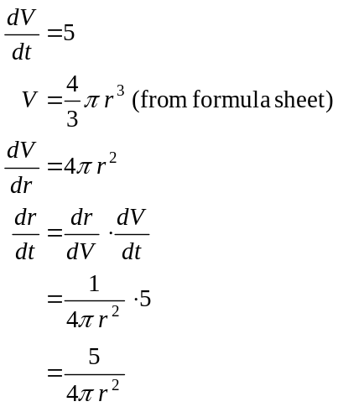
The answer is B.

Question 15

Do a quick sketch.
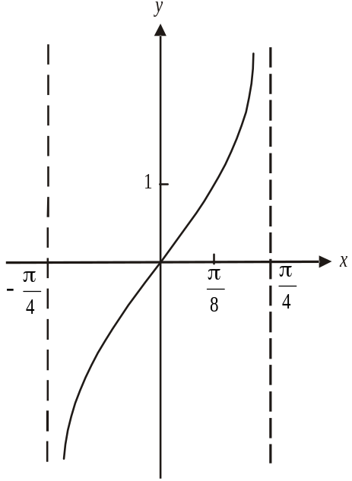

A dilation by a factor of 3 from the x-axis changes the rule 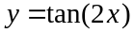 to become 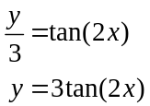

A reflection in the x-axis changes the rule to
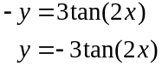
Note that the domain is not affected by these two transformations.
The answer is C.

Question 16

Since we have a probability density function,
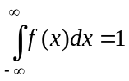
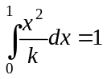
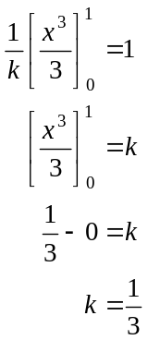
The answer is A.

Question 17

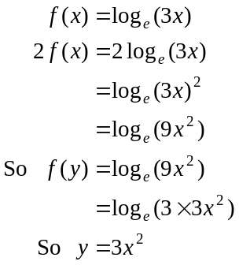
The answer is D.

Question 18
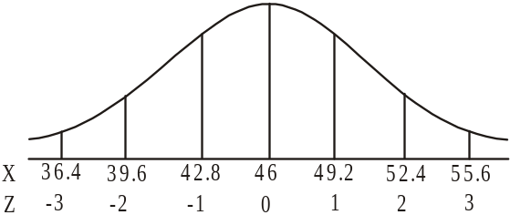
Let w = minimum weight required.
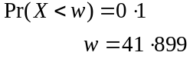
The answer is A.

Question 19

If n is small, there will be few rectangles and the approximation would be not as accurate as it could be.
If a is small, b could be large so this does not guarantee an increase in accuracy.
Similarly if b is small a could be very much smaller and an increase in accuracy is not guaranteed.
If h is small then the width of the rectangles will be small which ensures a lot of rectangles, which increases the accuracy of the approximation.
The answer is D.
Question 20

For a stationary point of inflection to occur 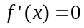. This only occurs at 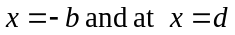.
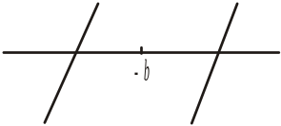
To the left of 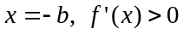 and to the right
of 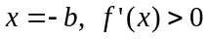 so we have a stationary point
of inflection at 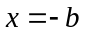.

Note that to the left of 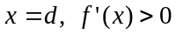 and to the
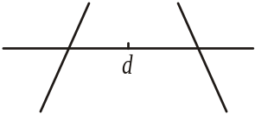
right of 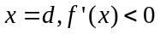
So we have a local maximum at .
The answer is B.

Question 21

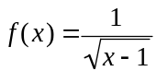, has a maximal domain.
That maximal domain is given by
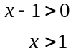
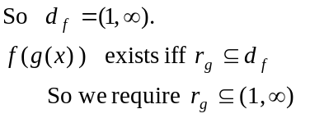
Method 1
The graph of 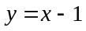 for 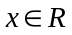 is shown in the diagram on the left below.
In order to restrict the range to 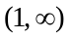, we are going to have to restrict the domain to 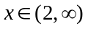 as shown on the graph on the right below.
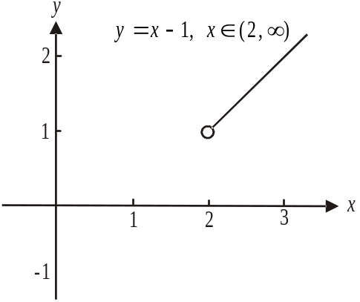
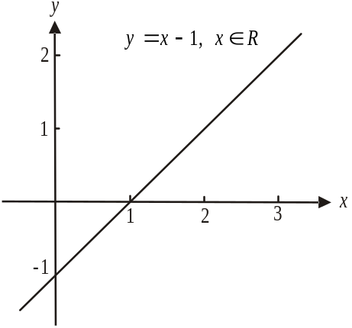

Since 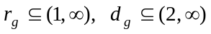.
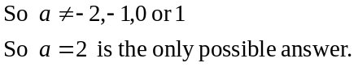
The answer is E.
Method 2
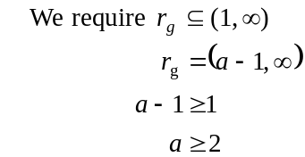
So 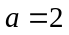 is the only possible answer.

The answer is E.

Question 22

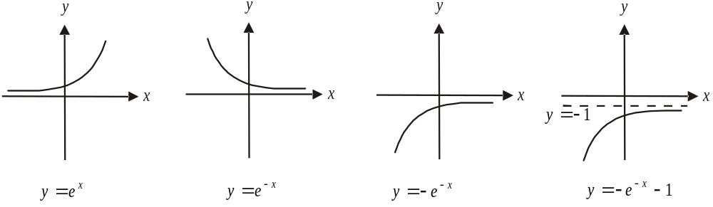

The only possible graph is E.
The answer is E.
SECTION 2

Question 1

- The graph of 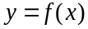 passes through 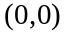
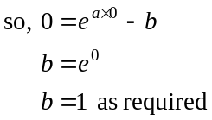
(1 mark)

- 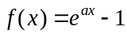
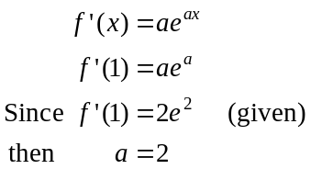
(1 mark)
(1 mark)

c. i. Note that the equation of the asymptote of 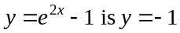.
Method 1
The graph of has undergone a reflection in the x-axis followed by a translation of 1 unit down. (1 mark) – reflection (1 mark) – translation

Method 2
The graph of has undergone a translation of 1 unit up followed by a reflection in the x-axis. (1 mark) – reflection (1 mark) – translation

  - Method 1
After the reflection in the x-axis the rule 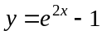 becomes 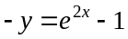 so 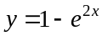. (1 mark)
After the translation of 1 unit down, becomes 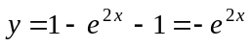. So 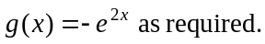 (1 mark)

Method 2
After the translation of 1 unit up, the rule becomes 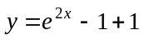 so 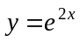. (1 mark)
After the reflection in the x-axis, becomes 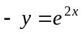 so 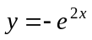. 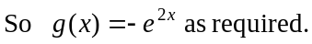 (1 mark)

- Solve 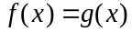 (1 mark)
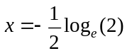
So 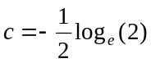 as required. (1 mark)

e.
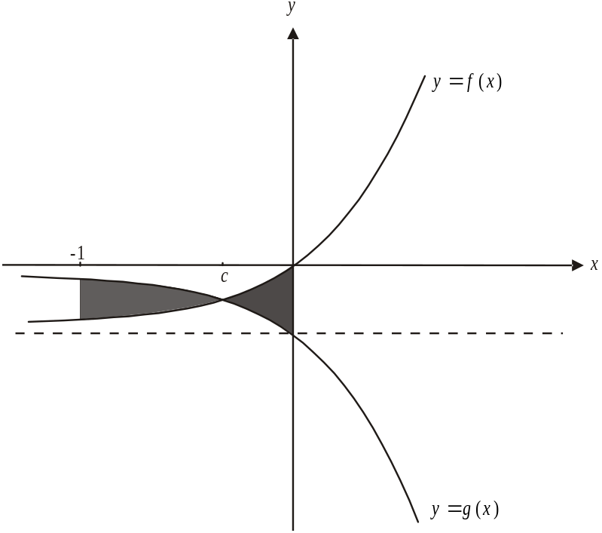

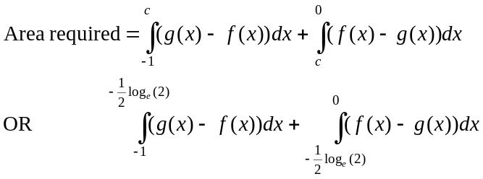

(1 mark) for first integrand (1 mark) – for second integrand
and terminals and terminals

i. 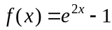
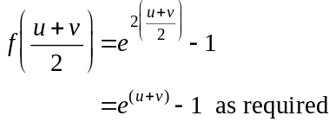
(1 mark)

  - To show
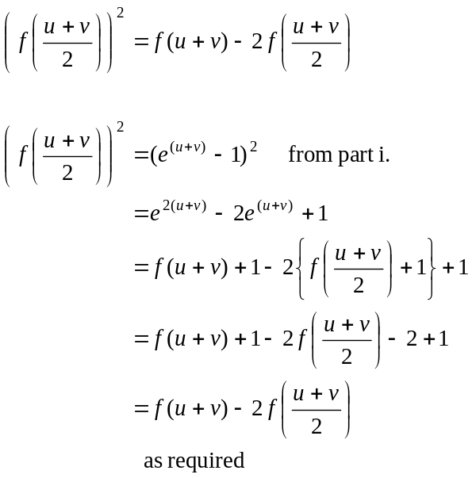
(1 mark)
(1 mark)
(1 mark)

Total 15 marks
Question 2

a. i. 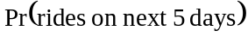
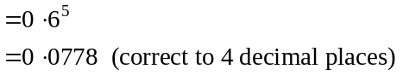
(1 mark)
  - This is a binomial distribution with 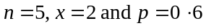.
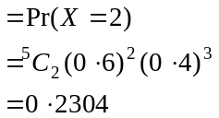
(1 mark)
(1 mark)

b. i. 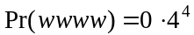
(1 mark)
(1 mark)
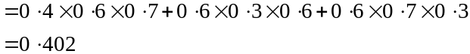
(1 mark)
(1 mark)
- Use the transition matrix

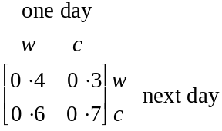
(1 mark) – for transition matrix
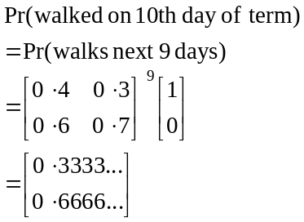
(1 mark) – for giving matrix expression including the power of 9
So the probability that Jordan walked on the tenth day of term is 0.3333(correct to 4 decimal places).
(1 mark) – correct answer
- Method 1
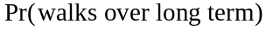
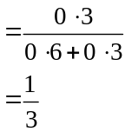
Over the long term Jordan will walk on 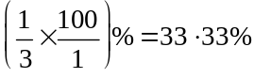 (correct to 2 decimal places).
(1 mark)
Method 2
Find the steady state.
Let 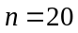
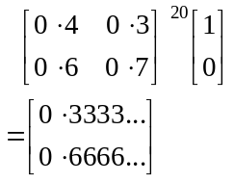
Using our result from part iii., we see that a steady state has been reached so
the probability that Jordan will walk over the long term is 33.33% (correct to 2 decimal places). (1 mark)

- i.
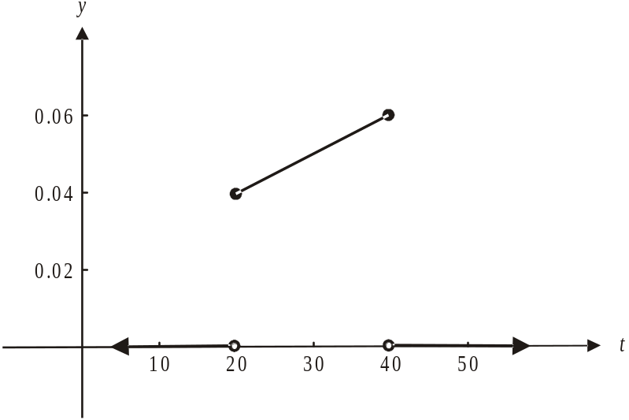

(1 mark) correct linear function and
included endpoints for 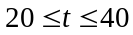
(1 mark) correct marking of function along t-axis

- From the graph, we see that the mode is 40; that is, the value of t with the highest probability; that is, the highest value of 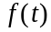.
(1 mark)

- Let
Solve 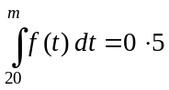
(1 mark)
(1 mark)
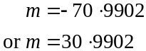

Since 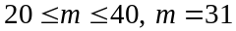 minutes (to the nearest minute).

(1 mark) correct answer

Total 17 marks

Question 3
- 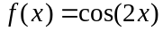
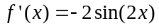
(1 mark)
- The gradient of the tangent is 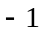 when
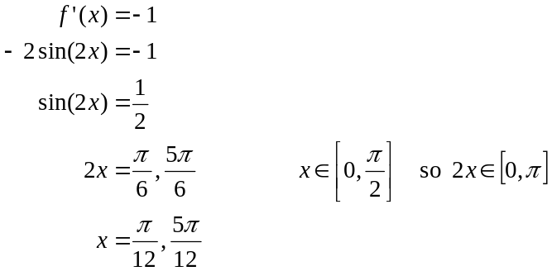
(1 mark)
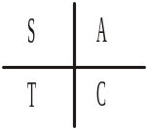

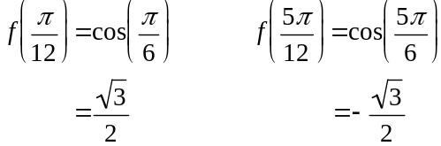
Required points are 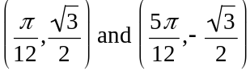.
(1 mark)

c. i. Tangent passes through 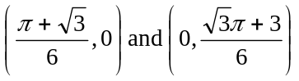.
Method 1
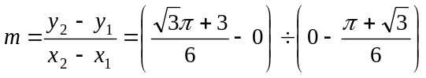
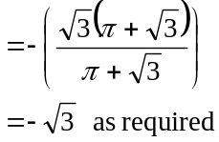
(1 mark)
Method 2
Note that the gradient must be negative since the tangent is sloping up to the left.
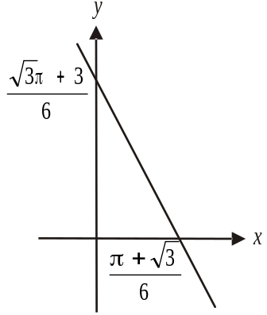
Gradient of tangent is given by
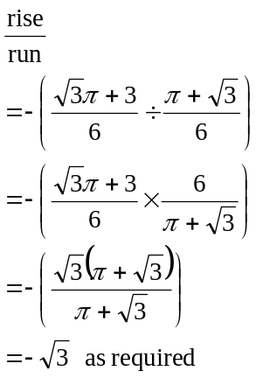
(1 mark)
ii. 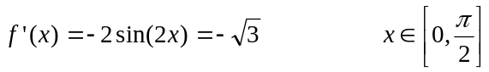 (1 mark)
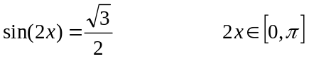
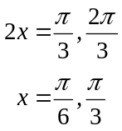
(1 mark)

iii.
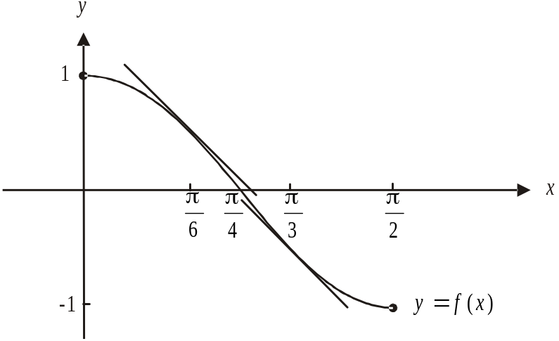

The x-intercept of the tangent we require is 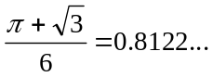
Now 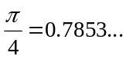
From the diagram above, we can see that the tangent we require must pass through the point where 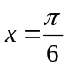. The other possible tangent which passes through the point where 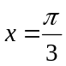, has an x-intercept which is less than 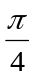 and therefore less than 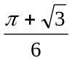. (1 mark)
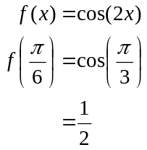
Point of tangency is 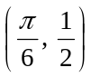. (1 mark)

- Do a quick sketch of the graph of 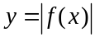.
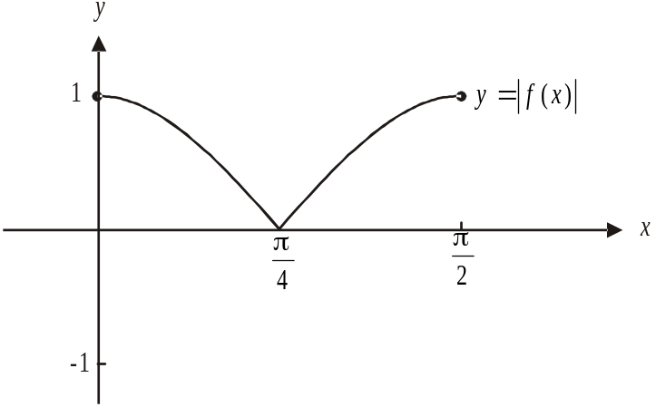

The minimum value of 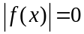. (1 mark)
The maximum value of 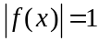. (1 mark)

- 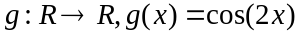
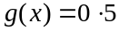

Method 1 – using CAS
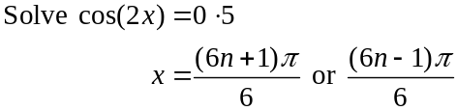
(1 mark)
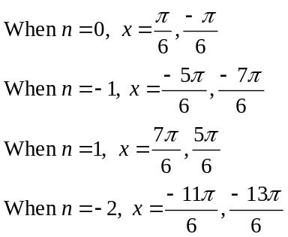
The values of x start to repeat.
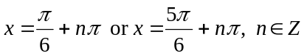
Alternatively, 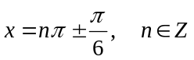.
(1 mark)

Method 2

Solve that is, for one period of the graph of 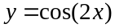.
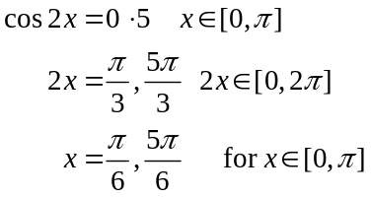
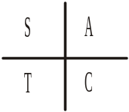
(1 mark)
For ,
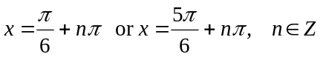.
Alternatively,
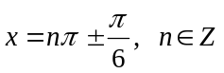.
(1 mark)
Total 12 marks

Question 4

- Solve 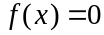
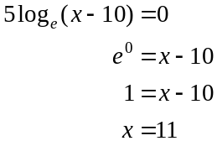
So as required.
(1 mark)

- Method 1 – using CAS
Find the inverse function of 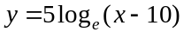
So 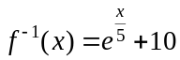
(1 mark) – correct rule

Method 2 – by hand
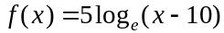
Let
Swap x and y for inverse.
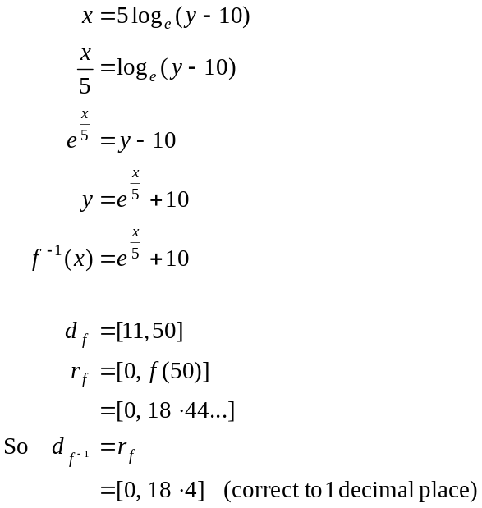
(1 mark) – correct rule
(1 mark) – correct domain

- Since the graph of 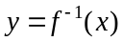 is a reflection of the graph of in the line , the floodlit areas to the north and to the east are the same.
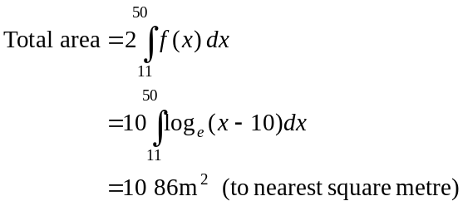
(1 mark)
(1 mark)

- Find the x-coordinates of the points of intersection between 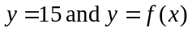 and between 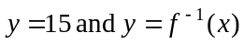.

Method 1 – using CAS
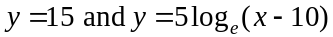 intersect when (to 2 decimal places)
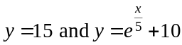 intersect when (to 2 decimal places)

So
(1 mark) correct values
(1 mark) correct brackets or inequality signs

Method 2 – by hand
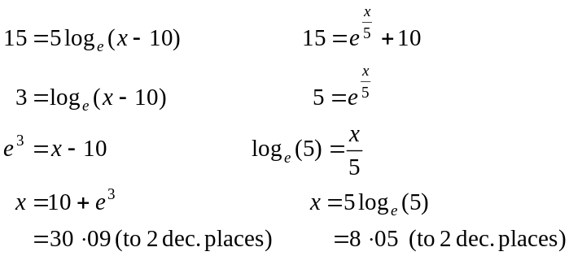
So
(1 mark) correct values
(1 mark) correct bracket or inequality signs

e. i. 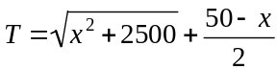
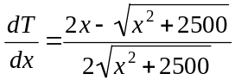
(1 mark)
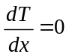 for minimum.
(correct to 2 decimal places)
(1 mark)

      - seconds correct to 1 decimal place.
(1 mark)

f. To take the quickest path, Victoria runs to 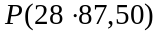 from part e. i.
The straight line from 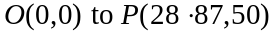 is given by 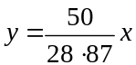. (1 mark)
Check whether this intersects with the perimeter of the floodlit area to the north given by 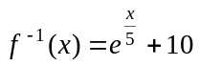.

Solve 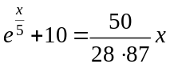.
There are two solutions .
So Victoria does enter the floodlit area.
(1 mark)

g. From part e. ii. the shortest time it takes is 68.3 seconds (to 1 decimal place).
The dogs have to run 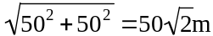.
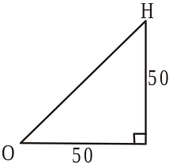
They run at 7m/sec.
It takes the dogs
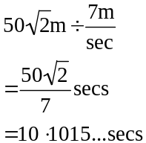
to get to H from O. (1 mark)
The dogs leave 60 secs after Victoria so they arrive 70.1015…secs after she leaves 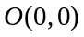.
So Victoria escapes the dogs; but only just!
(1 mark)

Total 14 marks

